HCI 440: Assignment 1: Observational Research
Name: Arjun Naik
Date: January 15, 2026
Site: Whole Foods Market (1550 N Kingsbury St, Chicago, IL 60642)
1. Executive Summary
In this assignment, I personally observed the working of the entire flow in the Whole Foods Market for around 45 minutes. The purpose was to experience how the store’s layout contradicts the digital interfaces that employees are forced to work with. My most important observation was how this tech-savvy store employs surprisingly use manual processes for its employees. I also noted how employees walk away from their high-tech counters to ask customers for prices because their systems are down. The most important thing is that System Status is invisible to the people who need it most while billing items by themselves.
2. Observation Summary
Context: I watched the front checkout lines and the deli counter from 12:00PM until 12:45 on a Thursday. It was a busy store. This made the bottlenecks very apparent.
Key Insights:
1. Efficiency Problem: The Paper List
I saw an employee stocking the shelves with dry goods. Even with the registers that track all sales digitally, this employee was using a clipboard with a paper list. He would look at the shelf, compare it with his paper, and mark a box.
The Problem: It felt like a tremendous waste of time. The list of papers printed is obsolete the moment it is printed. He would hesitate a few times to see if a certain item is out of stock or if it got moved. He even ended up walking all the way to the back warehouse to check one item. This is a textbook example of a ‘gulf of execution’, the information is in the computer, and the worker has no way to access it.
2. Communication Breakdown: The Standoff at the Butcher Counter
There's a long glass counter for meats and seafood, but there isn't an exact place to form a line. I have watched one customer standing at the very left end waiting for an order while a butcher is standing at the far right, cleaning a knife.
The Problem: was that they stood there for about 20 seconds, doing nothing. He thought that the customer was being ignored, but most probably the butcher is thinking that the customer is simply browsing. Since there was no "Order Here" sign or ticket machine, the communication totally failed until such time that the customer finally waved his hand in frustration.
3. Limitation of the tool: The failure in the lookup of "Flower Item"
At the central cashier, a client went to pay for a bouquet of flowers that did not have a tag with a barcode. The attendant, attempting to use the touchscreen to check it out, certainly wasn't successful in retrieving the correct code. She hit "Back" twice and scrolled down through a menu before giving up altogether.
The Problem: It was directed at the customer when she asked, “Do you remember how much it was?” Since the digital tool did not work in her favor, she had no choice but to opt for a verbal solution. It was a very risky move on her part, as the customer might have estimated a lower price. It was apparent that the price lookup tool was not flexible enough for un-coded items.
3. Application of Concepts to a Norman’s Design Principles
1. Missing Signifiers (Butcher Counter)
Norman writes about how the signifiers indicate locations for the action to take place. The butcher counter has a tremendous affordance but no signifier to go along with it. There are no indications of an arrow, a "Line Starts Here" mark, or a number dispenser. The lack of the signifier causes the user to wonder where to begin the activity resulting in the standoff I talked about.
2. Failed Constraints (Hot Bar Sneeze Guard)
It has a glass cover over the self-serve food area that is a physical constraint against contamination. Honestly, it doesn’t. I have seen people in bulky winter clothing reach for food directly under the glass screen. A physical constraint would force them at a physical level to do it in a safe way (such as a pot that has a top that must be lifted). A screen that relies on people doing their best just doesn’t make it.
Nielsen’s Usability Heur
1. Visibility of System Status (Self-Checkout)
The scanning area is a jumbled mess of people leaning forward to get a look. The registers do not have a tall light or an electronic sign that says OPEN or CLOSED. System status is not visible unless standing right in front of the screen. I saw several cash registers where someone started to walk to, realized they were broken or occupied, and had to do the "walk of shame" back to the line."
2. Match Between System and Reality (Restocking)
The worker's paper list, The System, appeared to be ordered by SKU or perhaps alphabetically. However, the Real shelves is ordered by brand or category of food. Because of this, it's necessary for the worker to have to do a lot of cognitive translation for determining where the correct location of the item would be listed.
4. Domain Definition & Evaluation
I am concentrating on the gap between the electronic database (prices/stock) and the actual shelves/customers.
Criterion | Score | Thoughts
1. Accessibility | 3 | Everyone buys groceries. It’s easy to explain the problems because everyone has experienced them.
2. User Access | 3 | I don't need special permission to watch people shop. The workers are right there in the open.
3. Diversity | 2 | Shoppers are diverse, but the workers I’m analyzing have specific training, so they aren't exactly general users.
4. Focused Scope | 3 | I can narrow this down to just Item Lookup or Queue Management so it doesn't get too big.
5.Interaction Scope | 3 | The solutions would be screen-based (better POS UI) or physical (better signage), which fits the class project.

Geographies of Land
If I think back to Whole Foods and compare it to your typical gas station convenience store, such as 7-Eleven, the difference is complexity. Everything has a barcode scan at 7-Eleven. Now, Whole Foods has barcoded items, organic codes versus non-organic codes, and then there's weighed produce and bulk bins. The challenge is the universal scan, or items making sounds, yet not scanning; it's scanning items with length, width, or height. Basically, Whole Foods has too many items to scan.
5. Reflection
What struck me most?
As it happens, I talked to one of the security guards by the door and she said something crazy to me: the exit gates don't go off for unbilled produce. They don’t go off if the item has a specific high-value security tag, like on expensive vitamins. It's pure Security Threat it works based on users thinking and trust, but not actually in operation.
What had not been visible until now?
I never really realized how much memorization we require from cashiers. For some reason, I had thought that the screens just told them everything, but watching the cashier fumble with the flowers made me realize that they are supposed to memorize hundreds of PLU codes and that when they can't remember one, the system offers them almost no help.
What Was Challenging?
It was difficult not to judge the users. “Why aren't they reading the screen?" was my instinct when I saw someone having trouble at the self-checkout lane. I had to remind myself to take a step back and think “Why isn't the screen letting them read it?" Blame-shifting from the user to the system is not as easy as it seems.

6. Appendix
A. Field Notes Excerpt
- 12:05 PM: Watching the self-checkout line. It's moving slow.
- 12:08 PM: Observation: Guy walks to Register 4, realizes screen is black, walks back. No "Closed" sign. (System Status fail).
- 12:17 PM: Observation: Butcher counter confusion. Customer on left, worker on right. No eye contact. (Missing Signifiers).
- 12:42 PM: Observation: Flower bouquet with no barcode. Cashier asks customer "How much is this?" Workaround used.
- 12:45 PM: Verified: Security officer confirmed the gates don't scan for unpaid items, only manual overlook through CCTV and on-premises staff.
B. Photos
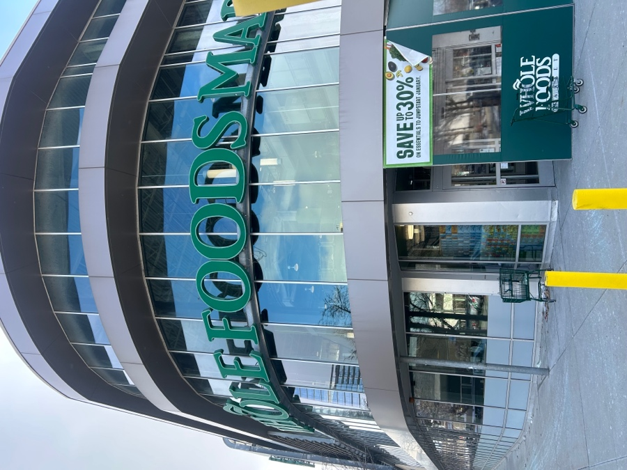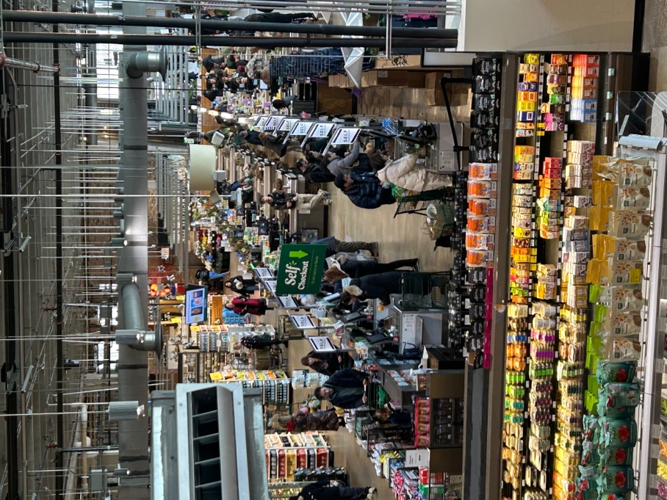
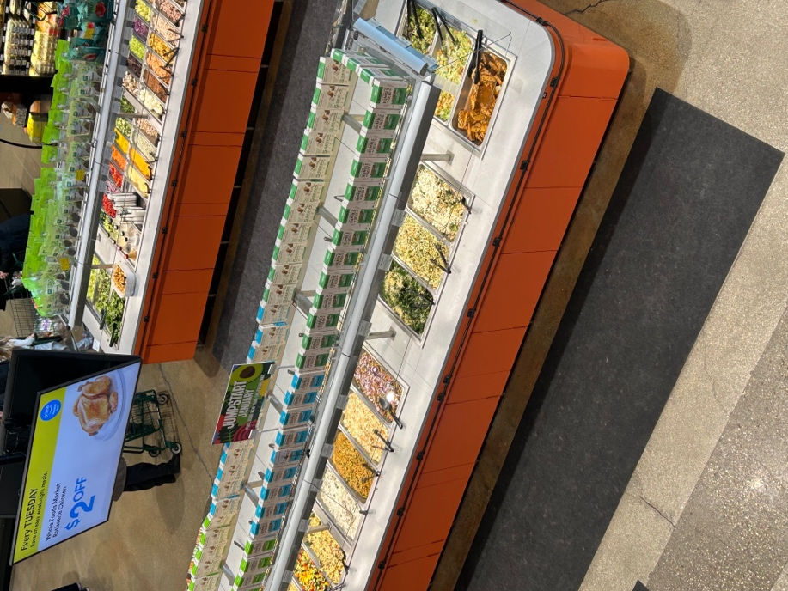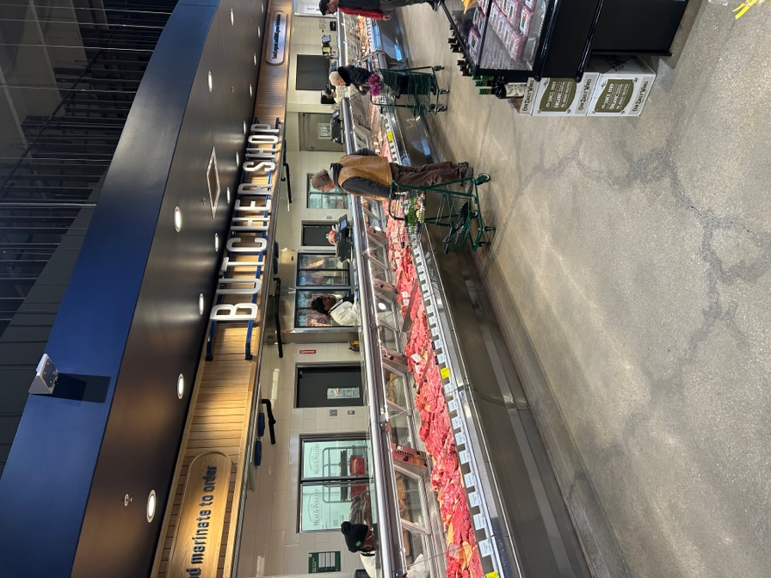

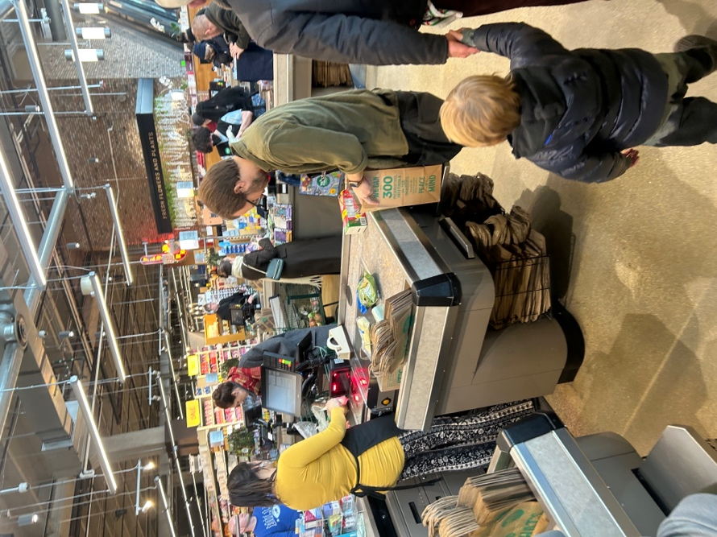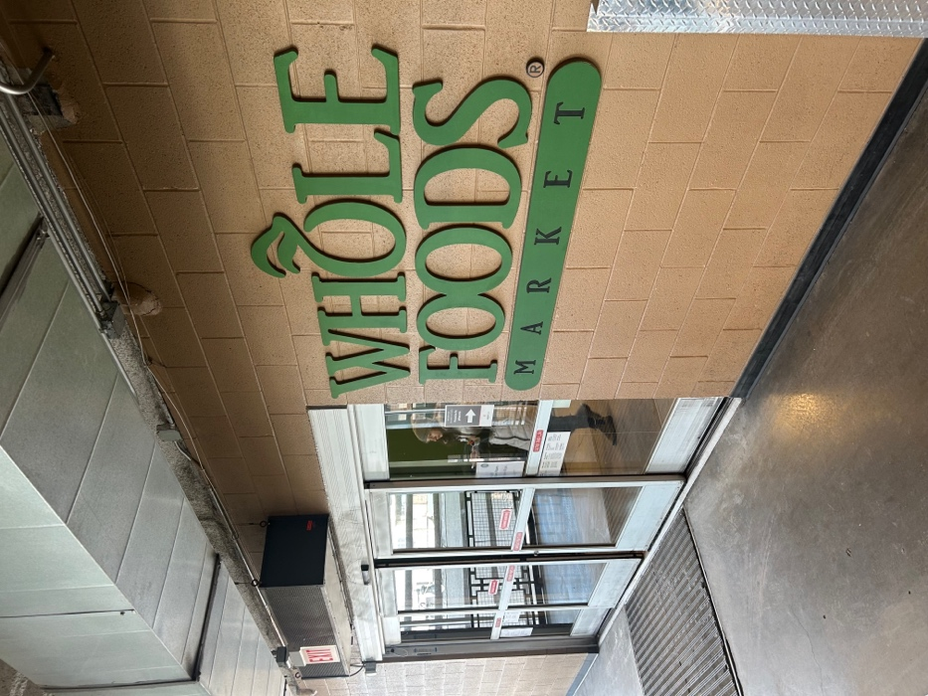

C. References
- Considine, J., & Cormican, K. (2016). Improvements in the self-checkout process in retail. Proceedings of the International Conference on Industrial Engineering and Operations Management, 8–10.
- Nielsen, J. (1994). 10 usability heuristics for user interface design. Nielsen Norman Group. https://www.nngroup.com/articles/ten-usability-heuristics/
- Norman, D. A. (2013). The design of everyday things: Revised and expanded edition. Basic Books.
- Wang, C., Harris, J., & Patterson, P. (2012). Customer choice of self-service technology: the roles of situational influences and past experience. Journal of Service Management, 23(1), 54–78

